Note: Include this page only when adding / amending / deleting a document. If using this document as a record, this Revision History page can be omitted.

REVISION HISTORY

Revision no | Date | Description of Changes | Reason for Revision | Revised by | Approved by
2 | 19 Apr 13 | - Add revision history page  - Revise reference list | - Recommendation from Stage 2 audit | RDPlacido | RDPlacido
3 | 08May 13 | - Move Audit matrix to Reference section from Records section | - Address NC - Others - 2013 - 0000299 | CMRojas | CMRojas
4 | 08 May 14 | -Change frequency of IQA from quarterly to semi-annually | - Address - CPIAR - 2014 - 0000367 | CMRojas | CMRojas
5 | 11 Dec 15 | - Added Disclaimer  - Changed the frequency of IQA  - Simplified the process flow | - Printing is sole responsibility of the person who printed it  Based the frequency on the pre-determined schedule stated in the Audit Program  Some steps are actually included in the previous steps. | RCGanal | ECVentura

I. Objective
To ensure that the Quality Management System constantly operates in line with the documented procedures and requirements.

II. Scope
This procedure defines the responsibility of the QMR to act as the IQA Chairman and lead auditor during the Internal Quality Audit. The IQA Team composed of trained auditors checks the compliance with the requirements of the standard. Activities covered by this procedure start from the scheduling of the IQA to implementation of actions as suggested by the results of the IQA.

III. Definition of Terms
Audit findings | These are the results of the evaluation of the collected audit evidence against the audit criteria. Audit findings are classified into:  - Conformity  - Nonconformity  - Opportunity for improvement  - Other observation
Nonconformity | This is a non-fulfillment of a requirement.
M | Major nonconformity. This may mean any of the following:  - The failure or total breakdown of a system to meet the requirements of an ISO 9000 clause or other requirements.  - A number of minor nonconformities listed against one clause
m | Minor nonconformity. This means a failure to meet one requirement of a clause of ISO 9001, a company procedure or other reference documents.
OFI | Opportunities for improvement. This may mean any of the following:  - A potential nonconformity  - A suggestion for improvement
O | Other observation – a compliment or a positive remark. (This is called an “other observation” because an opportunity for improvement is actually an observation also.)
DRC | Document Request for Control, a form used to input changes in documentation

IV. Procedure Details
RESPONSIBLE | ACTIVITY | INTERFACE
QMR  QMR  QMR,  Unit Heads  QMR  Auditors  Auditors, Unit Heads, QMR  Auditors, Unit Heads, QMR | 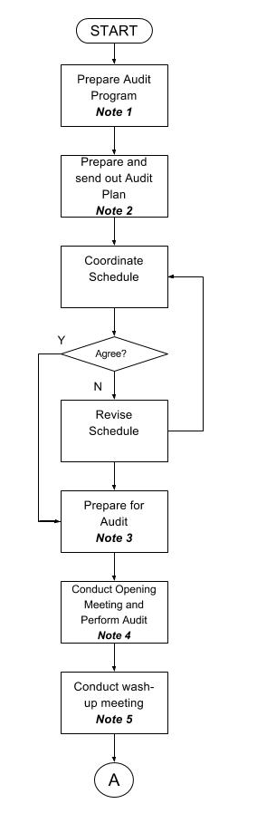 | ExeCom  Audit program  ExeCom  Audit Plan  Audit Checklist  Audit Matrix

RESPONSIBLE | ACTIVITY | INTERFACE
IQA Team,  Document Controller  IQA Team  IQA Team | 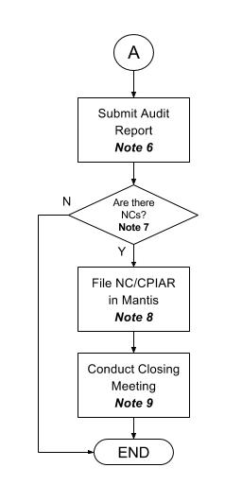 | Audit Report  Mantis

Notes:
- An audit program is prepared annually. The audit program for next year is presented to the ExeCom for approval, on the last quarter of the current year. It shall include the following:
• Processes and areas to be audited
• Audit criteria
• Scope
• Criticality – Definition of the criticality of the processes can change. Initially focus could be on the processes of business operations. Later, criticality can be based on statistics of audit findings.
• Frequency of audit – depends on the criticality of the process to be audited
• Pool of Internal Quality Auditors
• Schedule of audits

- At least a month before the actual IQA, the QMR prepares the Audit Plan. The Audit Plan contains the audit schedule for each unit and the corresponding auditors. Auditors are informed of their assignments.

- The auditors prepare for audit by first knowing what standards have to be checked on the unit that they will audit. They may refer to the Audit Matrix to see the standards applicable for each unit. Auditors write their questions or documentation of their preparation on the Audit Checklist.

- Perform audit according to the agreed schedule. While conducting the audit, the auditors will document their findings using their individual audit checklist.

- After the audit, the auditors, unit head and QMR will discuss the findings and observations for each unit. They will decide what nonconformities will be raised for each unit.

- The Document Controller shall file the IQA Records (Audit Checklist, Audit Reports, and IQA Summary) in the AWS bucket.

- The auditors confirm with the Unit Head and QMR the findings as to their classification. For audit findings which are categorized as opportunities for improvement (OFI), a CPIAR is raised if
- the OFI is a potential non-conformity against ISO standards, or
- if the OFI can badly impact or pose a risk to the business.

- The nonconformities that are validated by the QMR are addressed by the unit head through the CPIAR. The schedule of the follow-up monitoring on the non-conformity is set. The Unit Head and QMR implement the necessary action.
If changes in the documentation are needed, the DRC form is prepared and the CPIAR no is indicated in the DRC.

- The IQA Summary per Unit and per Clause will be presented by the QMR. This will show the extent of compliance per Unit and per ISO clause for the whole organization.

V. References
- Procedure for Corrective Preventive and Improvement Action
- Procedure for Documents Control
- Guidelines - Audit Matrix Per Process Group

VI. Quality Records
- Audit Program
- Audit Plan
- Audit Checklist
- Audit Report
- CPIAR in Mantis
- IQA Summary per Unit and per Clause
- Minutes of the Closing Meeting

